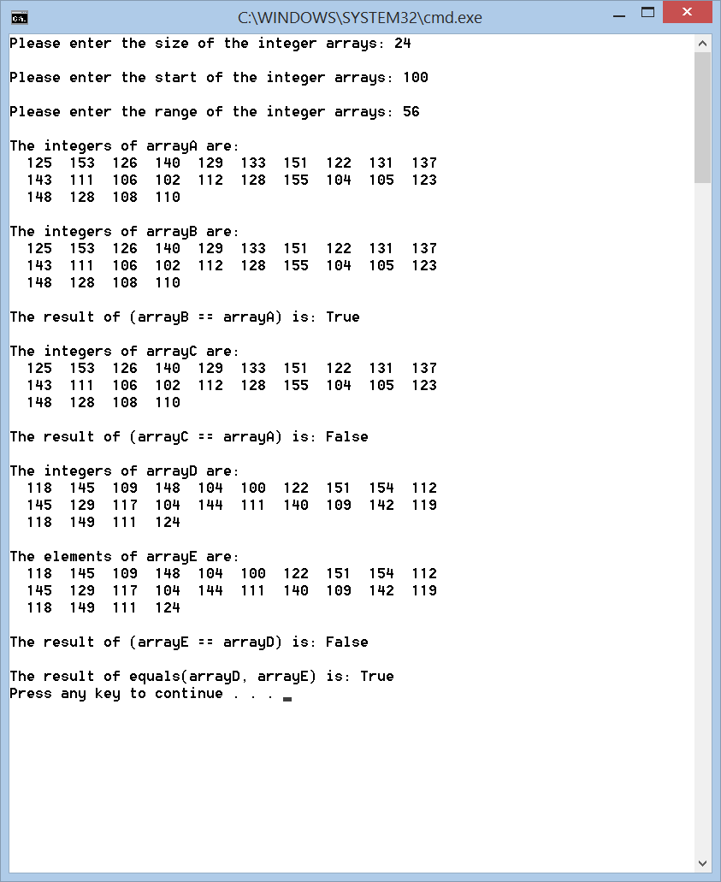DOS window of Lab4Ex1.java

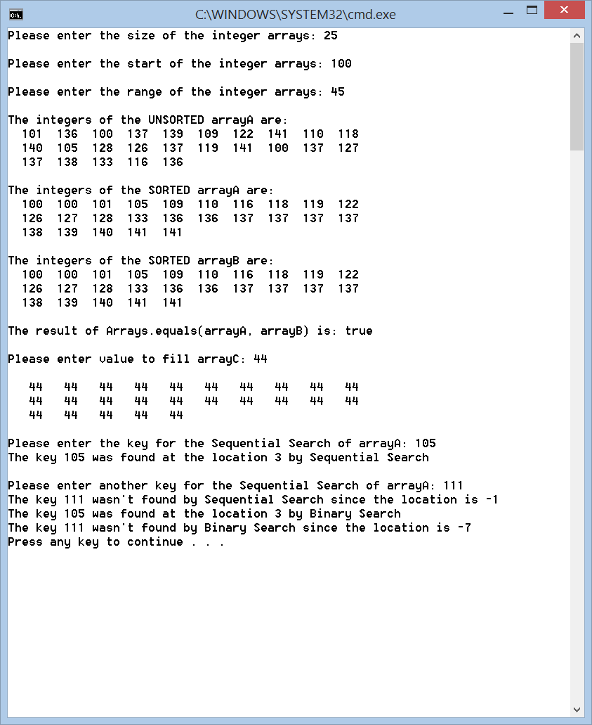DOS window of Lab4Ex2.java